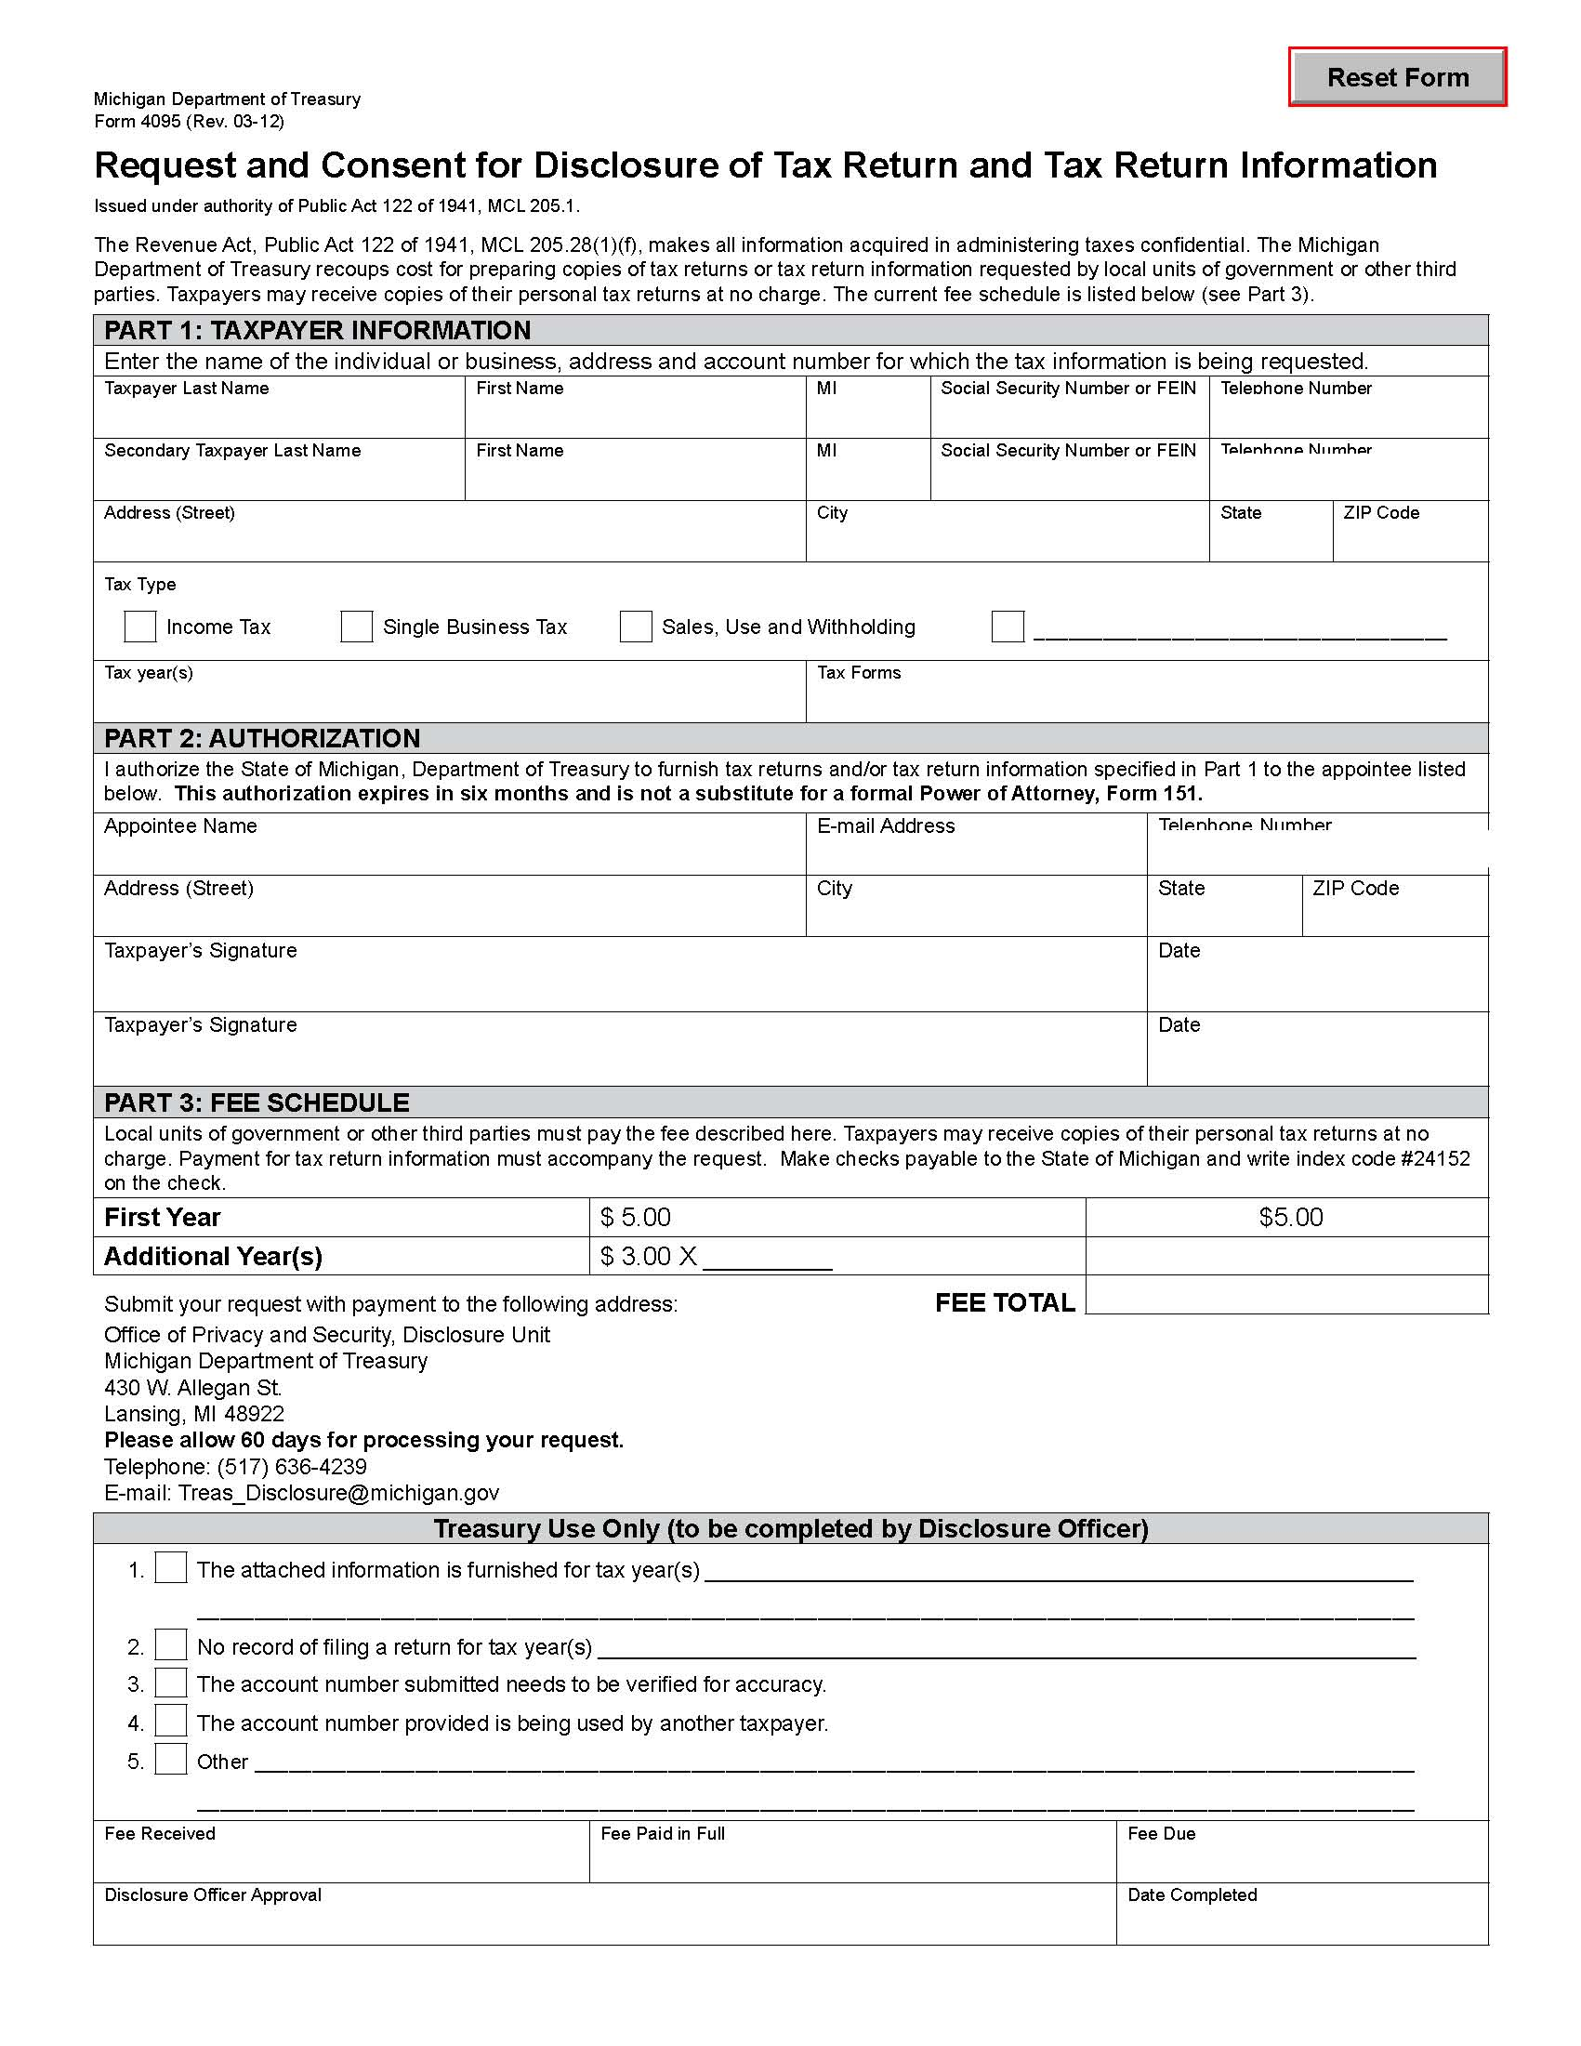

Order No. 01-28420 - 013
Joshua Caverly
xxx-xx-3555

Axiom Requisition Copy Service records@axiomcopy.com (877) 886-5090

2869 Jolly Rd Okemos MI 48864

1469 21 Mile Road

SBT, Sales and Use, Withholding, etc.

Cedar Springs
MI
49319

